Final Project

Smart Waste Management System

Sai Venkat Kumar Gunnapaneni,

Manaswini Challa,

Roschlynn Michael D’souza

Saint Louis University

Data Analytics and IOT

Anna Marbut

Introduction

Due to the rising amount of garbage produced and the demand for sustainable waste management techniques, Smart bin waste management systems utilizing IoT (Internet of Things) technology have attracted more and more interest in recent years. These systems monitor trash cans, gather information on waste levels, and transmit that information to a central server or cloud-based platform using a number of sensors and devices. Smart bin systems can automate waste collection, improve truck routes for waste collection, lower waste collection costs, and promote more environmentally friendly waste management techniques by utilizing IoT technology.

Ultrasonic, infrared, and accelerometer sensors, microcontrollers to manage and control system functions, a network interface to enable real-time communication between system components, and a server or cloud-based platform to store and analyze data gathered by the system are the main elements of a smart bin waste management system. Together, these elements make it possible to monitor trash levels in bins in real-time, send out automatic warnings and messages when bins are full, and analyze data to improve garbage collection and treatment procedures.

The use of IoT technology to develop smart bin waste management systems has a few advantages, such as improved garbage collection and transportation efficiency, decreased waste management costs, increased environmental sustainability, and improved public health and safety. Smart bin systems are positioned to play a significant part in encouraging sustainable waste management practices and guaranteeing a healthier environment for everyone as trash management becomes an issue that is becoming increasingly urgent in metropolitan settings.

The proposed smart waste management system uses two machine learning algorithms namely Logistic Regression and LSTM (Long Short Term Memory). With the help of these algorithms, we predicted the quantity of trash in the bin and the notification will be sent for the garbage collection.

IOT system design

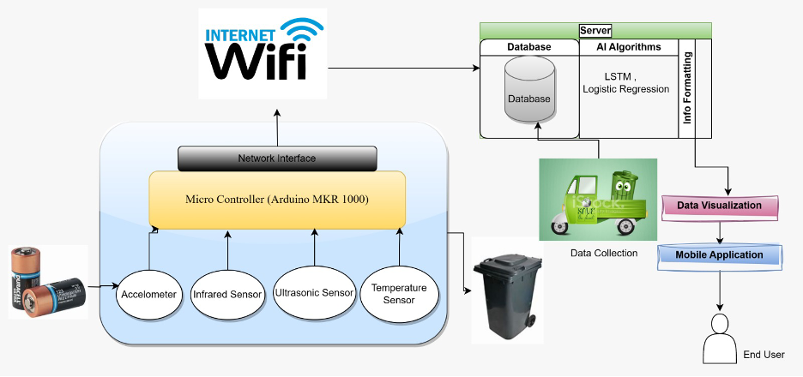Fig.1. Smart waste management system Iot design

Sensors in smart bins are powered by cable connections or, in some circumstances, solar energy.

Accelometer - Accelerometers can be used in smart waste management systems to detect the movement of waste in bins and to trigger actions such as sending alerts or initiating garbage collection processes.

Measurement Range: ±2g, ±4g, ±8g, or ±16g

Resolution: 16 bits

Operating Voltage: 1.8V to 3.6V

One issue is that accelerometers may not be able to precisely detect the kind and amount of waste in the bin, which might influence garbage collection systems' efficiency. Furthermore, if the accelerometer is not correctly calibrated or put in the bin, it may not detect waste movement effectively, resulting in false alarms or missed detections. Finally, if the trash bin is placed in a location with high vibrations or movement, such as near heavy machinery or on a busy street, the accelerometer may be unable to discriminate between the motion of the garbage and the external vibrations, resulting in waste detection inaccuracy.

Infrared Sensor - To prevent waste dumping outside the container, infrared sensors can be employed to monitor the area around the trash can. The infrared sensor detects trash near the trash can if it has been improperly disposed of. Then, it sets off an alarm system to warn people to properly dispose of their trash.

Detection Range: Up to 10 meters

Detection Angle: 180°

Operating Voltage: 3.3V to 5V

Because infrared sensors have a restricted detection range, they may not detect garbage that is too far away from the sensor. This can lead to false negatives, in which improperly disposed of garbage is not identified, and littering. Limitation in separating trash from other items: Infrared sensors may have difficulties identifying waste from other objects in the surroundings, such as animals or tiny detritus. This might cause false positives, in which the sensor is triggered by items other than garbage, resulting in unneeded alarms and notifications.

Ultrasonic sensor – It is the main heart component of smart waste management. The level of trash cans is sensed using ultrasonic and fill-level sensors to determine whether they need to be emptied. It is connected to a microcontroller or a computer using appropriate wires or wireless protocols such as Bluetooth or Wi-Fi. A program is written read the sensor data and process it to determine the fill level of the bin. Threshold levels are set for the fill level of the bin, which will trigger alerts or initiate garbage collection process when crossed.

Measurement Range: Up to 5 meters

Resolution: 1mm

Operating Voltage: 5V

The poor precision of ultrasonic sensors in detecting translucent or soft objects, as well as their sensitivity to influence from ambient conditions such as temperature, humidity, and air currents, are two limitations of it.

Temperature sensor - temperature sensors can help in identifying potential issues such as waste decomposition or fire hazards, and enable the implementation of proactive measures to address them. They can also be used to monitor the effectiveness of waste treatment processes such as composting or incineration.

Measurement Range: -55°C to 125°C

Resolution: 0.0625°C

Accuracy: ±0.5°C

Operating Voltage: 3V to 5V

Temperature sensors have two limitations: they are susceptible to interference from electromagnetic fields and have reduced accuracy when sensing temperature gradients or fast changes in temperature.

Micro Controller

The microcontroller regulates and keeps track of the smart bin's many operations, including opening and closing the lid, regulating the temperature inside the bin, and controlling power consumption. By placing the system into sleep mode when it is not in use and reawakening it when it is, the microcontroller controls power usage. It offers the intelligence and control required to make waste management procedures effective and efficient.

The microcontroller aids in optimizing waste collection, reducing waste, and enhancing overall operating efficiency by gathering and processing data, regulating and monitoring bin functions, and interacting with other system components.

The system requires an ARM Cortex-M0, M3, or M4 CPU with a clock speed ranging from 16MHz to 100MHz, flash memory capacity ranging from 64KB to 512KB, RAM capacity ranging from 4KB to 128KB, and an operating voltage ranging from 1.8V to 3.3V.

Network Interface

The network interface of a smart waste management system permits real-time communication between sensors, microcontrollers, and other system components. The interface, for instance, can be used to send information from accelerometers, temperature sensors, and ultrasonic sensors to a central server or cloud-based platform for processing and analysis.

Additionally, alarms and notifications to waste management staff can be sent via the network interface when a bin is full or when the temperature of the garbage reaches a predetermined level. Additionally, based on pre-established rules or algorithms, the interface can be used to start activities like waste collection, treatment, or recycling. In this project, we are using Internet(WIFI) as our network interface.

This system's Wi-Fi module runs on the 2.4GHz frequency range and supports the 802.11b/g/n Wi-Fi standard at up to 150Mbps. It has a 3.3V operating voltage and can generate up to 20dBm of power.

Server

The server consists of Database where we store all the received processed data through Wi-Fi from the microcontroller. Later, required algorithms such as Logistic Regression , LSTM and many more can be performed on this stored data and predictions can be made. The predicted is formatted in more interactive way to the end user.

Data Visualization

An essential component of a smart waste management system is data visualization, which helps waste management staff to obtain knowledge and make decisions based on the data gathered by the system. To present the data in a relevant and usable fashion, visualizations like charts, graphs, and maps are created using dashboard called tableau. The visualizations are analyzed to identify patterns, trends, and anomalies in the data, and to make informed decisions about waste collection, treatment, and recycling processes.

Data Cleaning and Processing

We have collected the following dataset from UCI Repository database which consists of smart bin trash data in numerical format. This dataset consists of attributes namely the container Type, Recyclable fraction, class, and various fill level values for each container.

Class: This column indicates whether the container was emptied or not.

FL_B, FL_A, and VS: These columns contain numerical fill level measurements related to the containers.

FL_B_3, FL_A_3, FL_B_12, and FL_A_12: These columns contain additional fill level numerical measurements with different levels of threshold related to the containers.

Container Type: This column indicates the type of container being measured.

Recyclable Fraction: This column indicates whether the container is recyclable or non-recyclable.

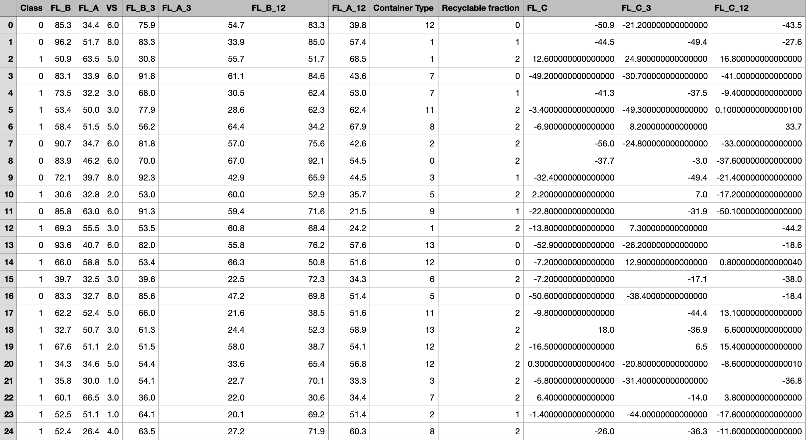Fig. 2. Data after cleaning and processing by removing the null values.

Logistic Regression

Based on a set of input variables, the statistical machine learning method known as logistic regression can be used to estimate the likelihood of a binary result (i.e., either 0 or 1). It is frequently used in classification issues, where the objective is to determine if a specific input belongs to one class or another. This algorithm operates by employing a logistic function to model the relationship between the input variables and the output variable. Any real-valued input can be translated by the logistic function into a number between 0 and 1, which represents the probability of the binary outcome. The logistic regression procedure calculates the log chances of the binary outcome using the input variables and their corresponding weights (also known as coefficients or parameters), and then transforms these logs into probabilities by applying the logistic function.

Preprocessing data - Data preprocessing involves separating the data into training and testing sets and removing any outliers or missing values.

Training the model - Using the training data, we developed a logistic regression model to forecast the garbage bin's fill level based on inputs

Testing the model – This step involves running the model on the testing data and assess its accuracy using metrics like precision.

Deploy the model – When the model testing, validation is done, it can be deployed in the smart bin management system.

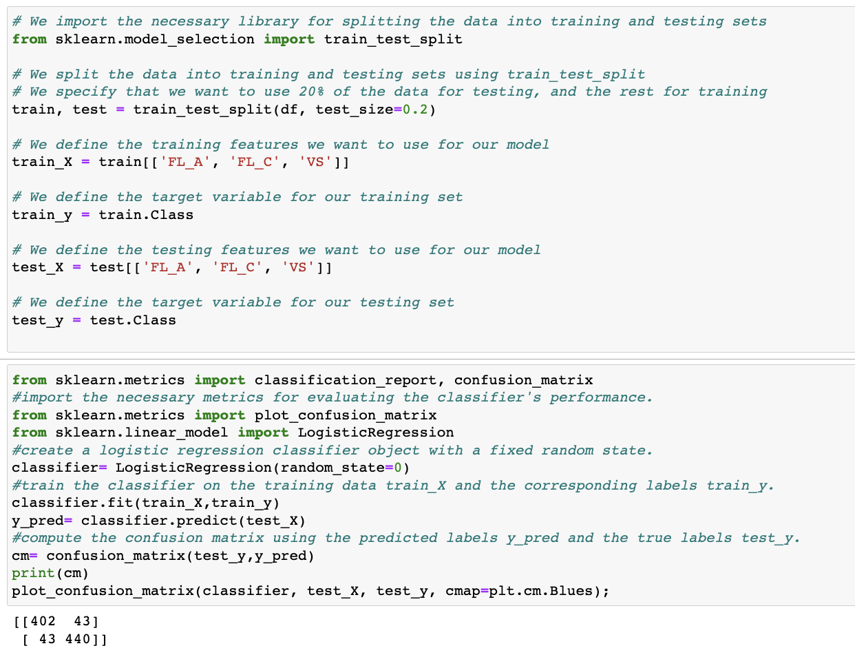

Fig. 3. Logistic regression model training.

We scaled the columns namely FL_B', 'FL_A', 'FL_C', and 'VS' to standardize the various fill levels of the containers. Here, standardization is done by subtracting the mean 0 each column and dividing it by its standard deviation, so that each column value has mean 0 and standard deviation as 1. This operation is done by the fit_transform method provided by sklearn.

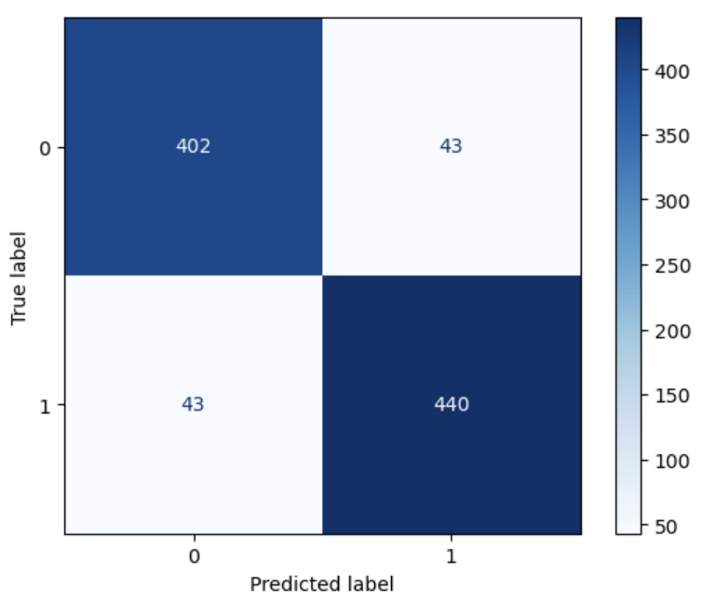

Fig. 4. Confusion Matrix using the predicted labels.

We have plotted the confusion matrix which takes actual target values for test_y and predicted target values (y_pred) and gives the matrix of true positives, true negatives, false positives and false negatives. Next, we have plotted the confusion matrix using the plot_confusion_matrix() and this plot gives the visualization of model performance.

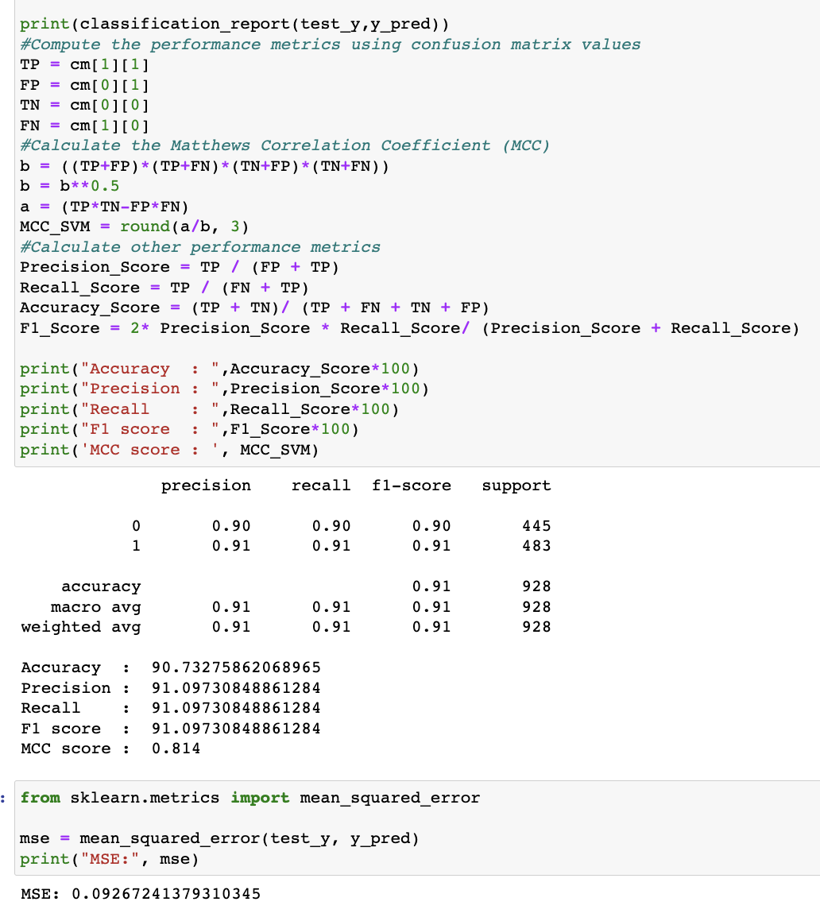

Fig. 5. Model performance

Finally the result of the logistic regression is recorded in a dataframe and saved. Also we tried obtaining the MSE value for this technique, and got it as 0.09 which represents the average squared difference between predicted and actual outcomes, indicating that the model has a low degree of error and strong predictive accuracy.

Long Short-Term Memory Model

Long Short-Term Memory is a type of Recurrent Neural Network (RNN) that is designed to handle the problem of vanishing gradients in traditional RNNs, which can occur when trying to train the network on long sequences of data**.** This architecture is used by LSTM prediction models to generate predictions from a series of input data. To discover the underlying patterns and relationships in the data, the LSTM network is trained on previous data.

By feeding the LSTM prediction model a sequence of input data and letting the network anticipate the subsequent value in the sequence, the prediction model may be used to make predictions on new, unseen data after being trained. When forecasting future values in a sequence using past data, LSTM prediction models are frequently employed in time series analysis and forecasting applications. The capacity of LSTM models to capture long-term dependencies in the data, which is essential in many time series analytic applications, is one of their main advantages. The LSTM model may keep a longer-term recall of the patterns and correlations in the data, even when these patterns occur over longer time scales, by using a memory cell to store data from prior time steps.

Preprocessing data – The data is preprocessed by removing any outliers or missing values and it is divided into training and testing data sets.

Creating LSTM model – Using a deep learning framework like PyTorch or Keras, an LSTM model is created.

Training the model – In this step, The LSTM model should be trained using the training set. The model recognizes the patterns and relationships in the data and creates precise predictions.

Validating the model – In this step, we evaluate the accuracy of the predictions using metrics such as mean squared error (MSE) from the testing set to validate the performance of the model.

As it enables waste management staff to anticipate the fill level of waste bins and take preventative action to optimize waste management procedures, LSTM is a useful algorithm to implement smart bin waste management system.

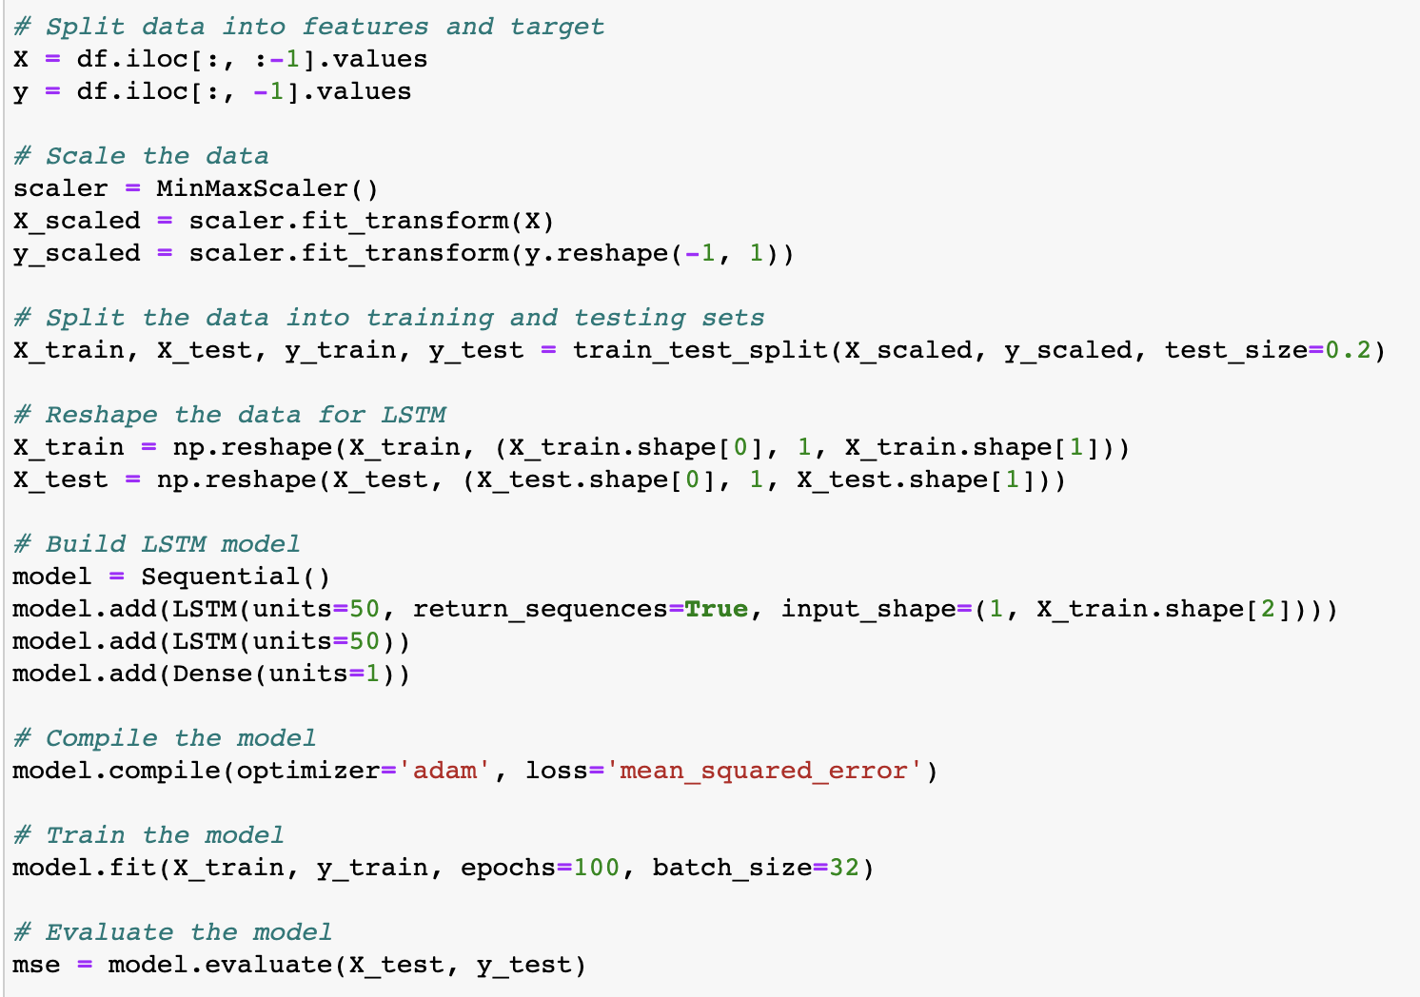

Fig. 6. LSTM Model training and evaluation.

We have first split the data into features, target and then performed scaling using the MinMaxScaler. Next, we have again performed splitting the scaled data to training and testing. Later, we reshaped the data to provide it as input to the LSTM model. To continue, we built an LSTM model using keras, with two LSTM layers and complied the model with adam optimizer and mean squared error loss.

Later, we trained and evaluated the model on the training data for 100 epochs with a batch size of 32. Later on when we predict the data we get the MSE value to be 5.32 * which represents the better model performance with lower errors.

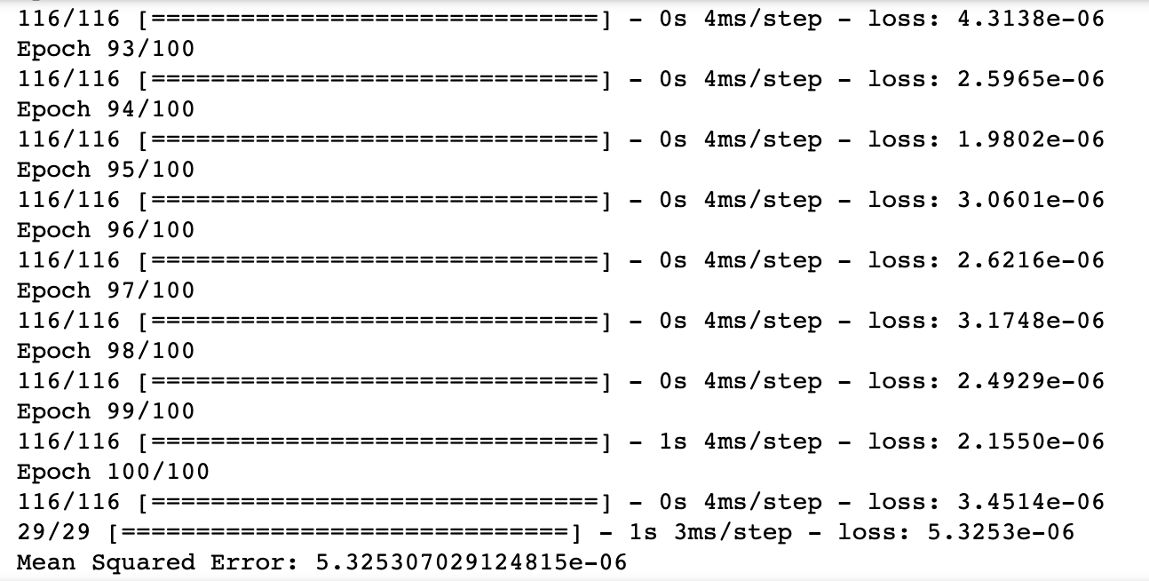

Fig. 7. Model Output after performing LSTM Technique.

Tableau Visualizations

After performing Logistic Regression and LSTM model on the smart_bin data, we now have the predictions available from our ML models, the next step we performed is visualization of the obtained predicted values and actual values. To perform this visualization, we have used Tableau platform and plotted the graphs between actual and predicted values of the trash fill levels of the smart bins. We have created two dashboards for Logistic Regression and LSTM models on tableau.

Logistic Regression Visualization

The above-mentioned Tableau graphic shows the results of a logistic regression study done on data from a smart waste management system. The dashboard offers a number of interactive charts and graphs that allow users to investigate the links between different input factors and the projected output variable (waste disposal behavior) and performed summary and status visualizations indicating the depth of the senor at predicted fill levels A12, A3 and actual fill level A.

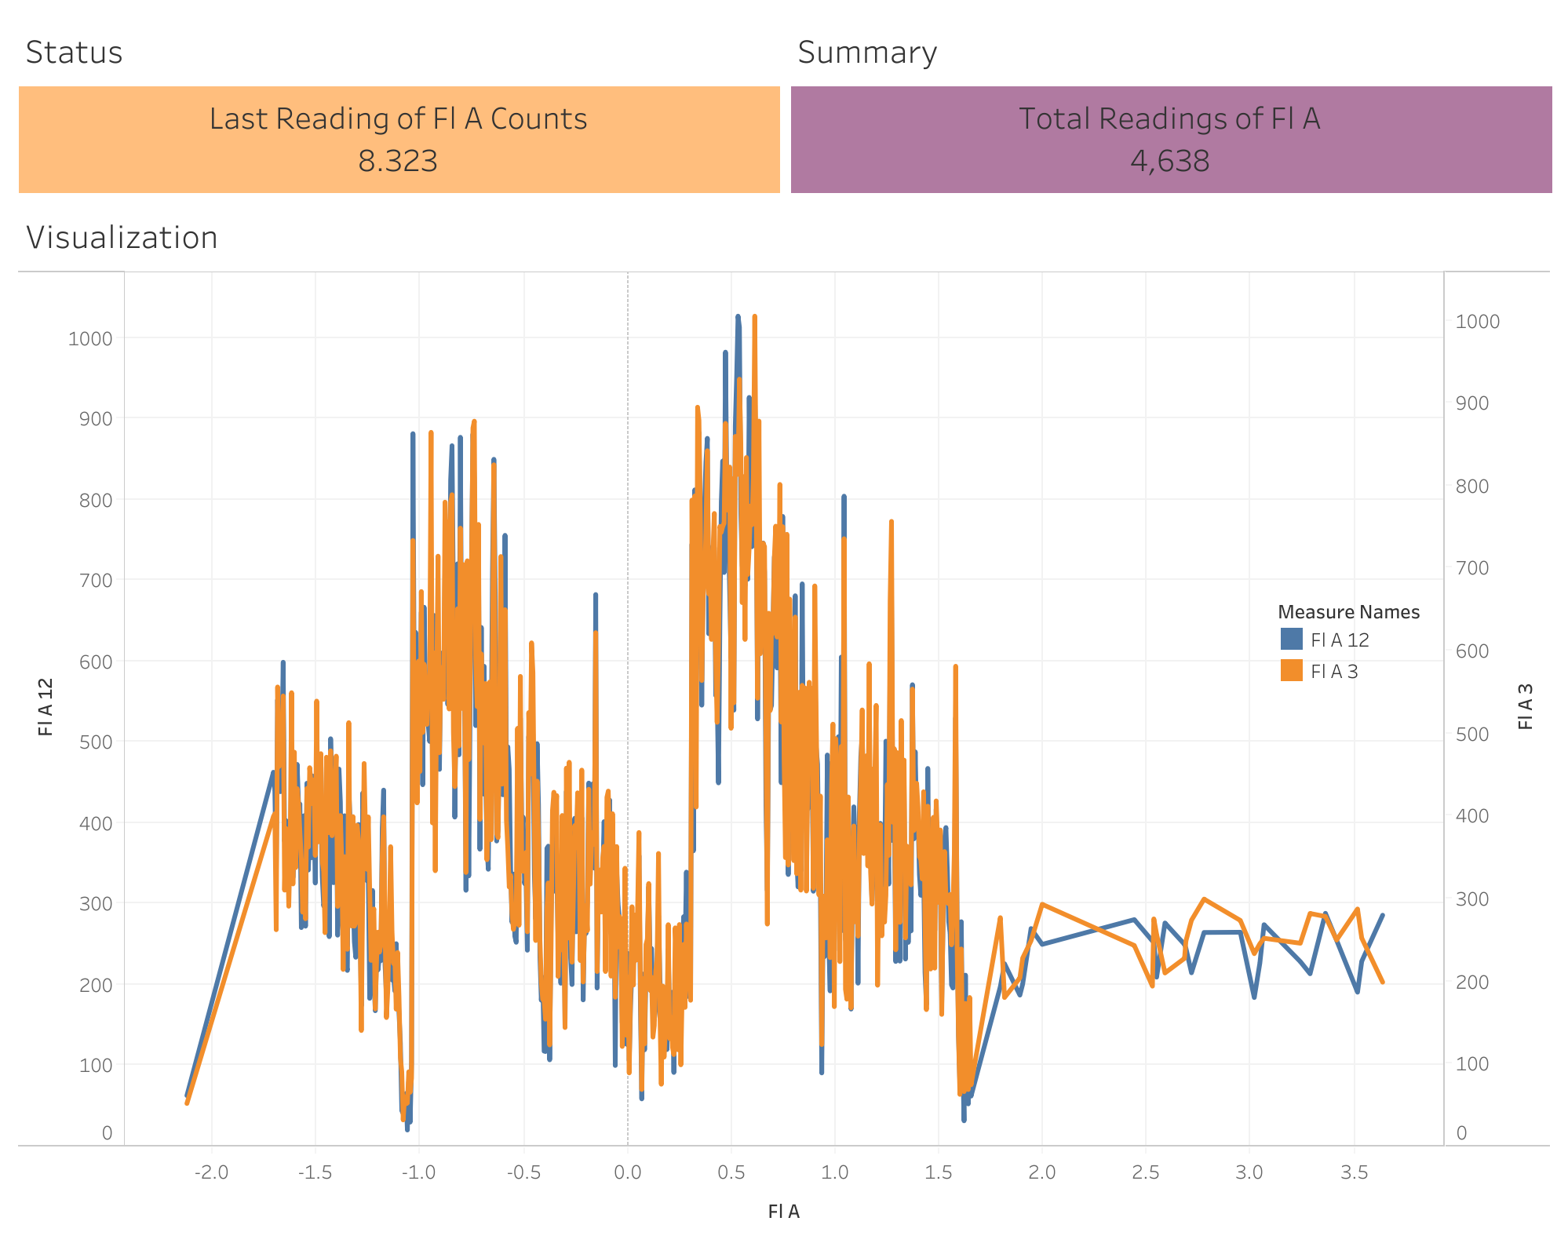

Fig. 8. Logistic Regression Visualization using Tableau Dashboard.

LSTM Visualization

The Tableau picture above depicts the findings of a LSTM regression research conducted on data from a smart waste management system. The dashboard includes a range of interactive charts and graphs that allow users to study the relationships between various input variables and the expected output variable (waste disposal behavior) and performed summary and status visualizations indicating the depth of the senor at predicted fill levels B12, B3, and actual fill level B.

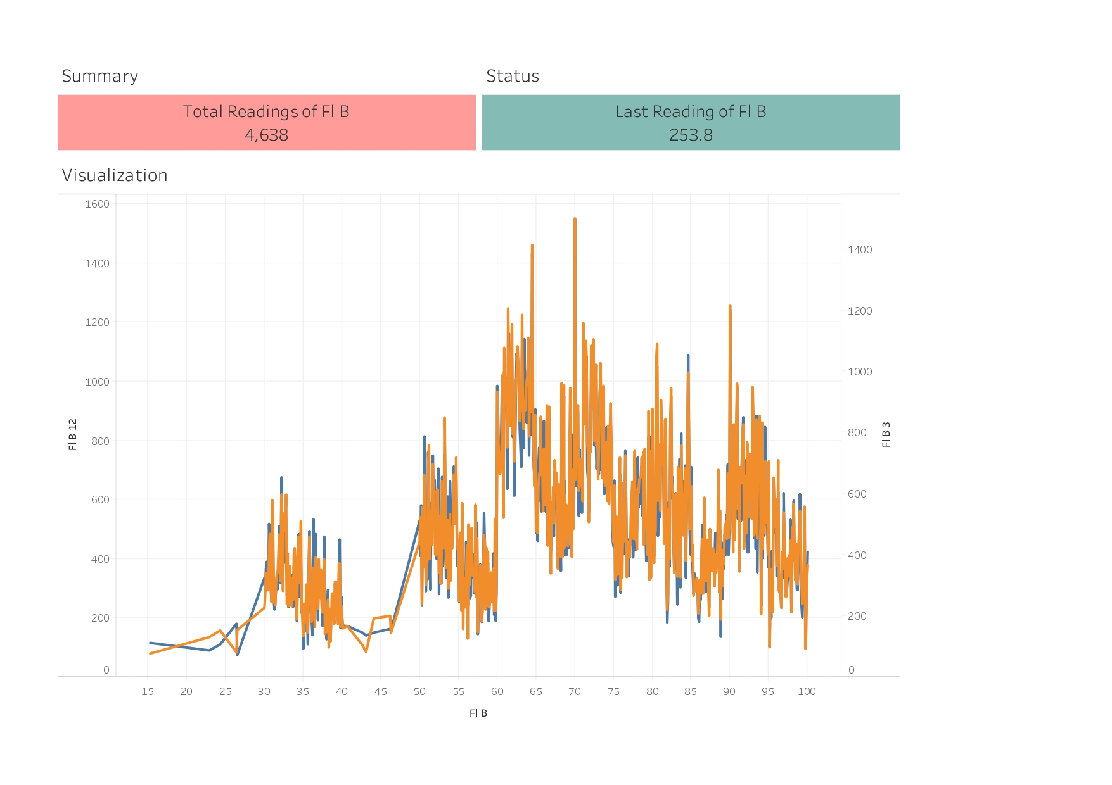Fig. 9. LSTM Model Visualization using Tableau Dashboard.

Conclusion

To begin, by using real-time data to track the fill level of the bins, the system can help to optimize garbage collection. This can lead to more efficient and timely collection, as well as cost savings from visits to empty partially filled bins.

Second, the system data may be utilized to study trash creation trends and give insights into waste management procedures in a specific area. This data may be utilized to optimize waste bin location and to better identify and handle waste management challenges. Third, by lowering the quantity of garbage that ends up in landfills, smart waste management systems can assist to lessen the environmental effect of waste management. Smart waste management systems can assist to reduce the quantity of garbage transported to landfills by promoting recycling and proper waste disposal practices, which minimizes greenhouse gas emissions and other negative environmental consequences.

Finally, as technology advances, smart waste management solutions will become even more effective and efficient. As more towns and municipalities use these systems, waste management methods will improve, benefiting both the environment and residents.

References

S. V, S. P, & Rani, J. (2019). Smart Waste Segregation and Monitoring System using IoT. International Research Journal of Multidisciplinary Technovation. <https://www.semanticscholar.org/paper/Smart-Waste-Segregation-and-Monitoring-System-using-S.-S./361f37a86f7db8a7fef957ded4a118ab0178d338>

V, Sowndharya & P, Savitha & S, Hebziba. (2019). Smart Waste Segregation and Monitoring System using IoT. International Research Journal of Multidisciplinary Technovation. 1. 1-10. 10.34256/irjmt1921.

Saha, S., & Chaki, R. (2023). IoT based smart waste management system in aspect of COVID-19. Journal of Open Innovation: Technology, Market, and Complexity, 9(2), 100048. <https://doi.org/10.1016/j.joitmc.2023.100048>

Vishnu, S., Ramson, S. R. J., Senith, S., Anagnostopoulos, T., Abu-Mahfouz, A. M., Fan, X., Srinivasan, S., & Kirubaraj, A. A. (2021). IoT-Enabled Solid Waste Management in Smart Cities. Smart Cities, 4(3), 1004–1017. <https://doi.org/10.3390/smartcities4030053>